**Assignment –6**

**Using Special Operators in Conditions.**

**1)** Write two different queries that would produce all orders taken on October 3rd or 4th, 1990.

**Answer –**

1. **select * from orders where**

**Odate=’1900-10-03’ OR Odate=’1900-10-04’;**

1. **select * from orders where**

**Odate between ’1900-10-03’ AND Odate=’1900-10-04’;**

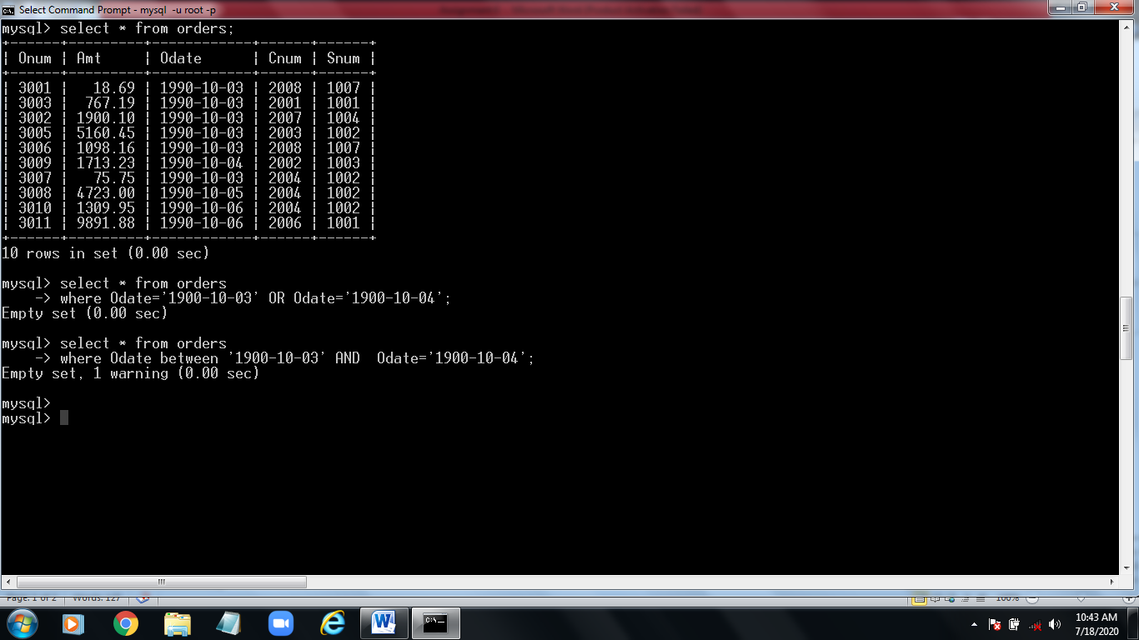

**2)** Write a query that selects all of the customers/salespeople serviced by Peel or Motika.

(Hint: the snum field relates the two tables to one another).

**Answer –**

**select * from customers**

**where Snum IN (select Snum from salespeople where Sname=’Peel’ OR Sname=’Motika’);**

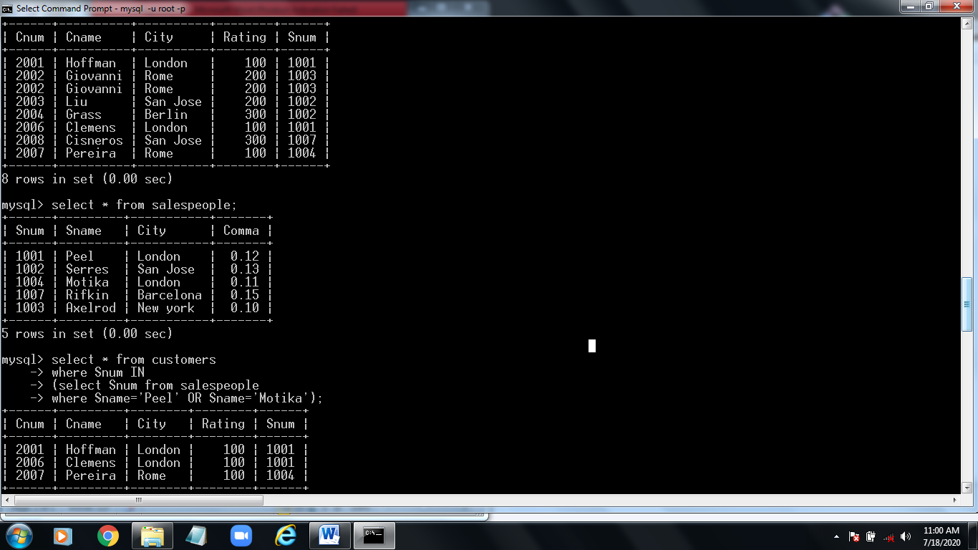

**3)** Write a query that will produce all the customers whose names begin with a letter from ‘A’ to ‘G’.

**Answer –**

**select * from customers**

**where Sname>=’A’ AND Sname<’H’;**

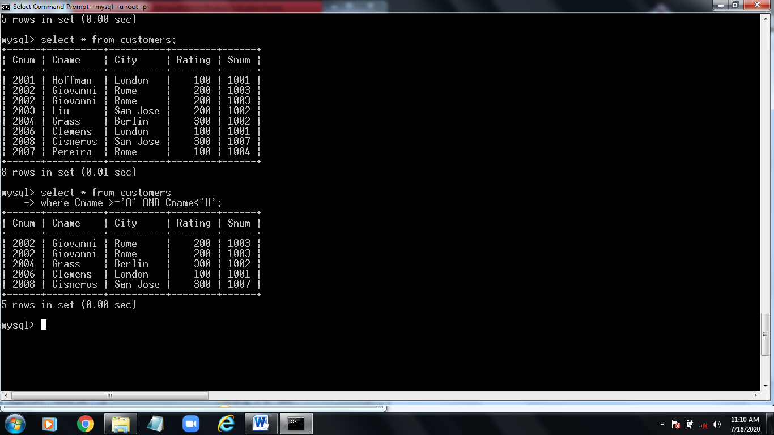

**4)** Write a query that selects all customers whose names begin with the letter ‘C’.

**Answer –**

1. **select * from customers**

**where Cname like ‘C%’;**

1. **select * from customers**

**where Cname >=‘C%’ AND Cname<’D’;**

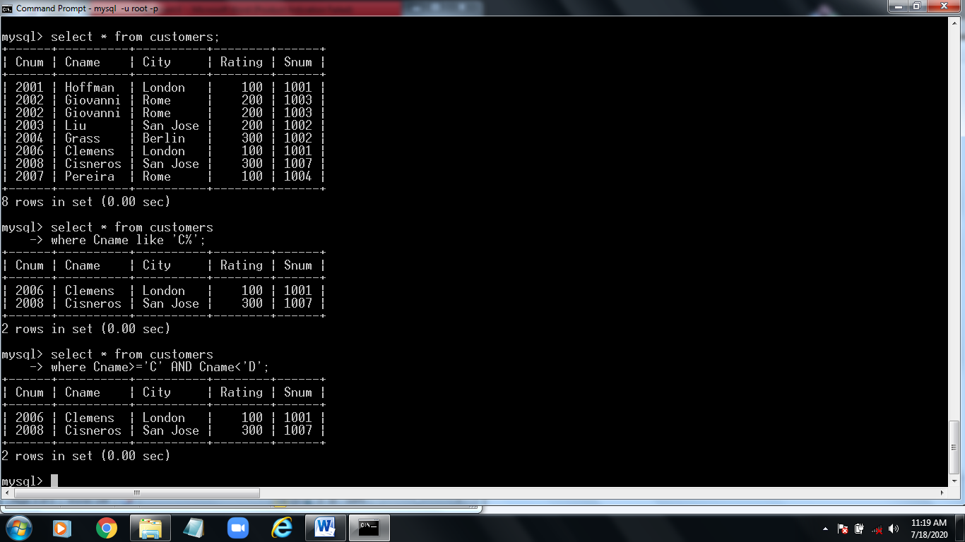

**5)** Write a query that selects all orders except those with zeroes or NULLs in the amt field.

**Answer –**

**select * from orders**

**where Amt <>0 OR Amt is not NULL;**

